Test case generator

User Story: HC-310 — Doctor Prescription Verification Workflow

Description:
The system should enable doctors to view medication details prescribed by other physicians or generated automatically from patient diagnosis. It should allow verification of dosage, potential interactions, and duplicate drugs. Once verified, prescriptions should automatically sync with the pharmacy module for patient dispensing.

Acceptance Criteria:

Given a doctor with access to a patient record,
When they open the prescription module,
Then all pending prescriptions should be displayed for verification.

Given a prescription with errors (dosage conflict or duplicate medicine),
When the doctor reviews it,
Then the system should highlight issues and provide AI-based recommendations for correction.

Given a verified prescription,
When it is approved,
Then it should automatically update the pharmacy dispensing queue.

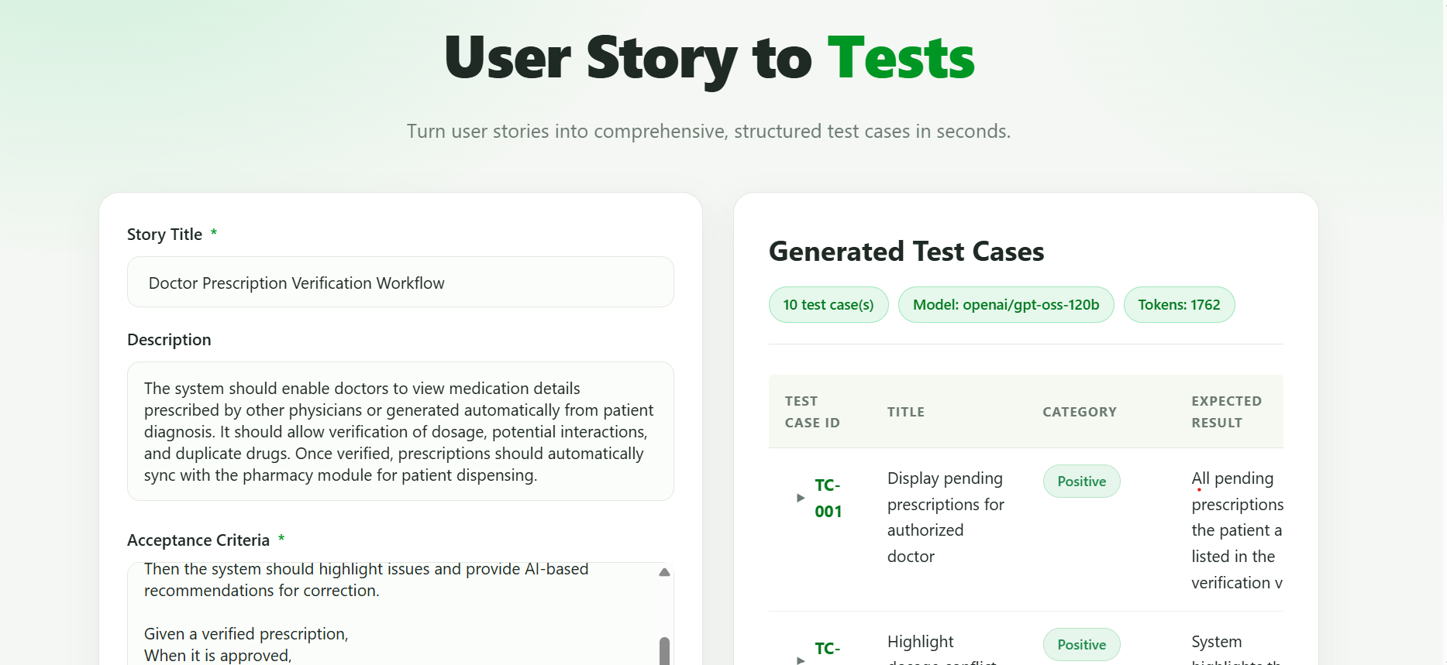

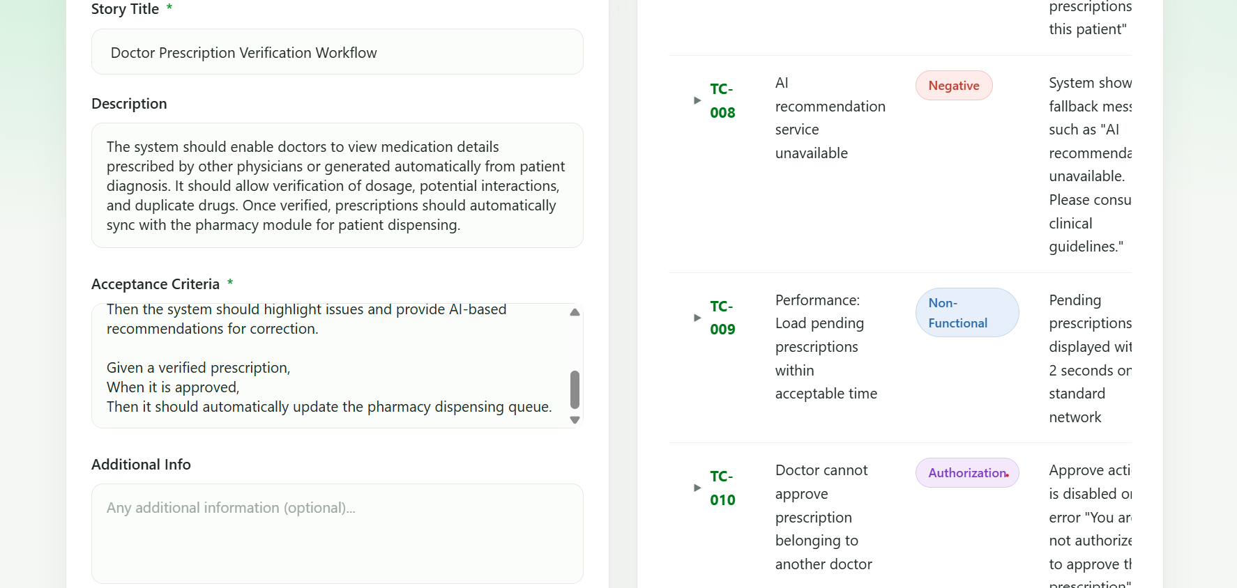

Task- Adding Summary field to the Test case Generator

ASK-

Act as a Senior Architect. We would want to have a new field on the Front end UI which is a Summary field on the left hand side of the UI below Story title field. Summary field would be helpful to add the summary of a user story. Analyse the files and function and tell us what are files and functions that will be updated. Mandatorily this implementation of having new field should not break the existing fields . I will review the change. Then we can proceed with implementation

Proceed with the implementation

